Answers
1. Computer software that harms computers, networks or data is known as malware.
Describe two different types of malware that exist. [6]
Virus (1) replicates code / infects other computers (1) without any intervention (1) to cause harm such as deleting or corrupting files (1).
Worm (1) replicates itself through a network/other computers (1) may cause no damage (1) may slow down networks (1) objective is to replicate (1).
Trojan horse (1) hides malicious code (1) inside a legitimate looking program (1) which when run/opened will be executed (1).
Spyware (1) is usually hidden in legitimate looking programs (1) and finds personal information on a computer (1) which will then be sent to a third party / hacker (1).
Adware (1) makes a large number of adverts appear (1) in multiple windows (1) so that the hacker/author of the adware makes money from the clicks on the adware (1).
Ransomware (1) once installed on a computer, encrypts the hard disk / storage (1) resulting in the user to be unable to gain access to their data (1) until a ransom is paid (1).
1 mark for the type of malware, 2 marks for the description.
Accept other forms of malware with an explanation of how it works.
2. Study the email on the following page
State three reasons which indicate that it is a phishing scam. [3]
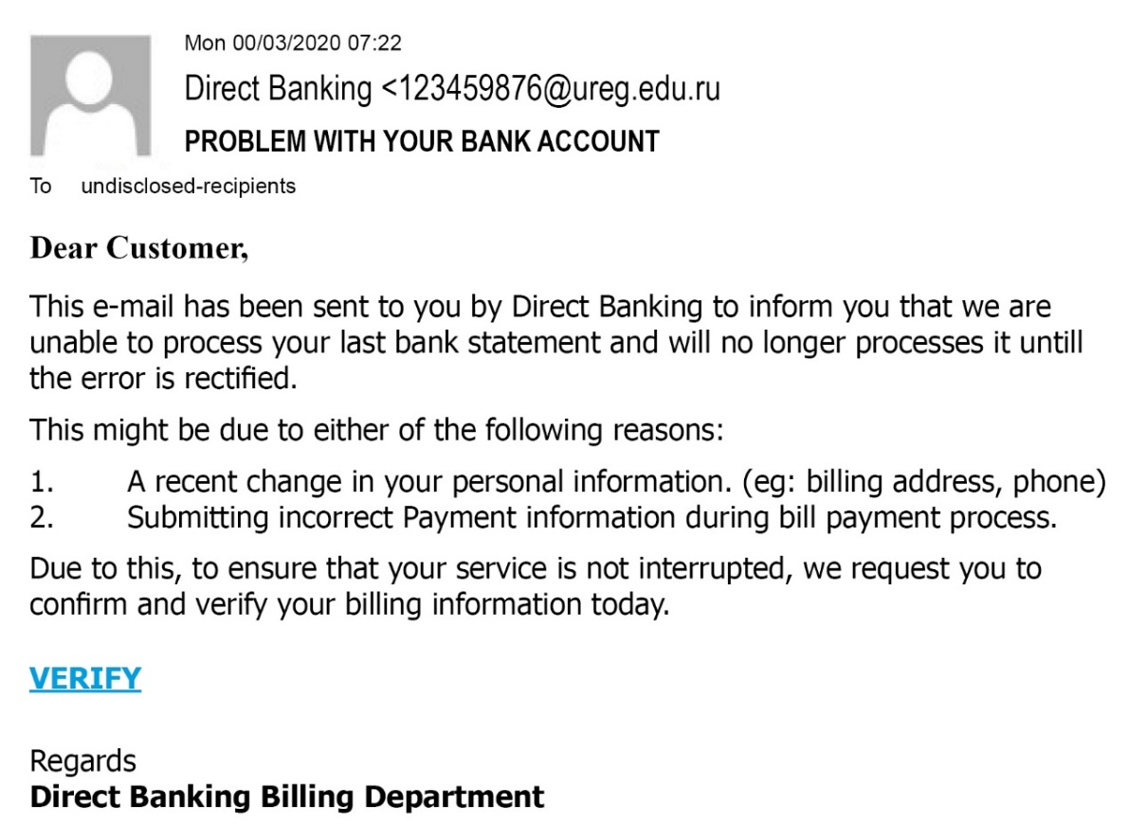
The email greeting is not personally addressed to the recipient (1).
It contains two spelling mistakes - ‘will no longer processes it until the error is rectified’ (1).
It asks you to click on a link (that doesn’t look legitimate) (1).
There is a request for personal information, i.e., ‘billing information’ (1).
The email address isn’t consistent with the bank name (1).

3. (a) Describe what is meant by a distributed denial of service attack. [2]
A DDoS attack is frequently aimed at company web servers (1) with the aim of overloading them or causing them to crash. (1) It may flood the server (1) with a huge number of requests which cannot be processed (1). This prevents legitimate requests from being services (1). In a DoS attack, one computer floods the server, whereas in a distributed denial of service (DDoS), many computers make the requests (1).
(b) Indicate in the right-hand column whether each of the following statements about a distributed denial of service attack is true or false. [4]
 | True or False
It aims to block an individual’s email account | False
The aim of the attack is to spread misinformation about an organisation | False
The motive is often black mail or revenge | True
It may cause the victim’s network to crash | True

[Total 15 marks]

